Machine Learning Lab
Project Report

Amazon Product Analysis and Recommendation System

Name | Ishan Ravishankar
Reg No. | 23FE10CSE00641
Section | J Batch-2
Semester | VI



SUBMITTED TO:

Dr. Arpita Baronia

Department of Computer Science and Engineering
Manipal University Jaipur
Jaipur, Rajasthan

Abstract
This project presents a comprehensive data analysis and product recommendation system built on a real-world Amazon product dataset containing 1,465 product listings across multiple categories. The system combines an Exploratory Data Analysis (EDA) pipeline implemented as a Jupyter Notebook, with an interactive Streamlit web application that enables users to search, filter, and receive personalised product recommendations in real time. Recommendations are generated using a TF-IDF cosine-similarity engine. The project demonstrates how structured retail data can be cleaned, visualised, and transformed into a deployable product recommendation engine for consumers.

1. Introduction

1.1 Problem Statement
Online marketplaces like Amazon host millions of products, making it increasingly difficult for consumers to identify the best options within their preferences, budget, and quality expectations. Without intelligent filtering, shoppers face information overload, browsing through thousands of results without a structured way to compare value, ratings, or discounts.
This project addresses two problems:
- How can raw, inconsistently formatted product data be cleaned and summarised to reveal meaningful patterns in pricing, discounting, and customer satisfaction?
- How can a lightweight recommendation engine surface the most relevant products for a user without requiring user history or collaborative data?

1.2 Importance of the Topic
E-commerce analytics is a fast-growing area of data science. Analyzing product pricing, discount strategies, and rating distributions helps consumers make smarter purchases and businesses refine their catalogues. Content-based filtering is especially useful when user interaction data is limited, making it practical for cold-start scenarios and smaller deployments. This project demonstrates a complete pipeline: from raw CSV ingestion and cleaning, through exploratory visualization, to a deployable interactive application.

2. Methodology

2.1 Dataset
The dataset (amazon.csv) contains 1,465 rows and 16 columns scraped from Amazon India, covering electronics and computer accessories. Key fields are listed below:
Column | Type | Description
product_name | Text | Full product title
category | Text | Product Category and sub-categories
actual_price | Numeric | Original listed price (₹)
discounted_price | Numeric | Current sale price (₹)
discount_percentage | Numeric | Discount as a percentage
rating | Numeric | Star rating (1–5)
rating_count | Numeric | Number of customer reviews
about_product | Text | Product description text
review_content | Text | Customer review body

2.2 Data Cleaning Pipeline
Raw data required several cleaning steps before analysis could begin:
- Price columns (actual_price, discounted_price) contained currency symbols (₹) and commas were stripped via regex and cast to float.
- discount_percentage contained a trailing % symbol was removed and cast to float.
- rating was stored as a string type despite containing numeric values, now converted with pd.to_numeric.
- Three derived features were engineered: savings (actual − discounted), value_score (rating × log(1 + rating_count)), and price_segment (Budget / Economy / Mid-Range / Premium / Luxury).
- The cleaned dataset was exported as amazon_clean.csv for use by the Streamlit app.

2.3 Exploratory Data Analysis
The EDA notebook amazon_analysis.ipynb is structured into 12 sections covering category distributions, price and discount analysis, rating patterns, top products, review word frequency, and price segmentation. All visualisations use Matplotlib and Seaborn, with charts arranged to facilitate direct comparison.

2.4 Recommendation Engine Algorithm
The recommendation engine is implemented using scikit-learn. The workflow is:
- Feature construction: Tokens are extracted from product name, category, and description, with higher weights for names.
- TF-IDF vectorisation: TfidfVectorizer builds the weighted term-document matrix.
- L2 normalisation: L2 scaling is applied automatically by the vectoriser.
- Retrieval: Similarity scores are computed with cosine_similarity, and the top N products are returned as recommendations.

2.5 Streamlit Application
The Streamlit app (app.py) exposes 3 recommendation modes:
Mode | Description
Search & Similar | Keyword search → select a product → TF-IDF similarity returns top-N most related items with similarity scores
Category Explorer | Browse all products in a chosen category, sortable by value score, rating, review count, savings, or discount
Top Rated | Leaderboard ranked by value score, pure rating, review count, or savings with a minimum 50-review threshold for rating-based ranks

3. Results & Output

3.1 EDA Visualisations
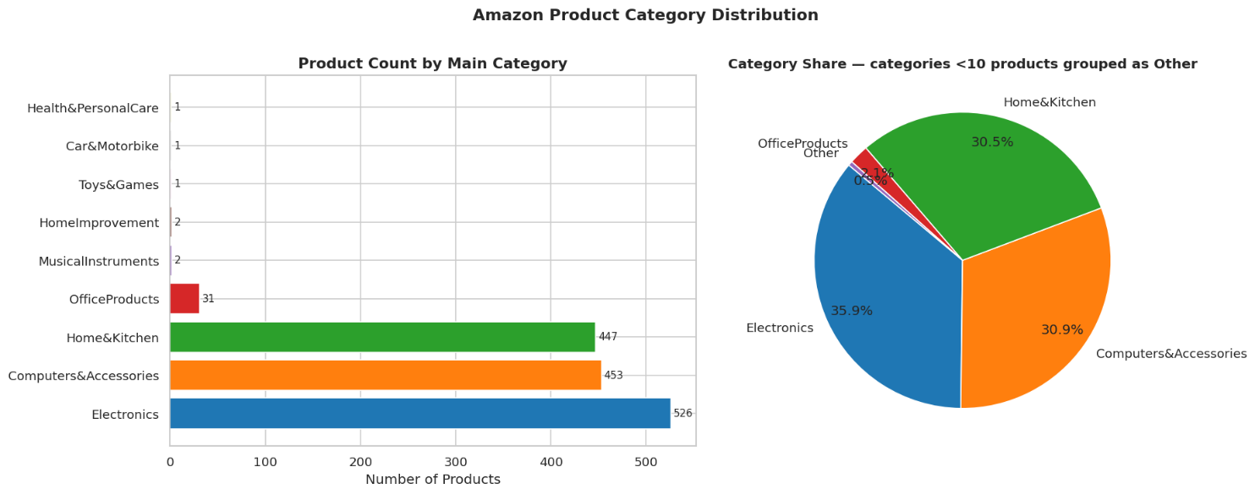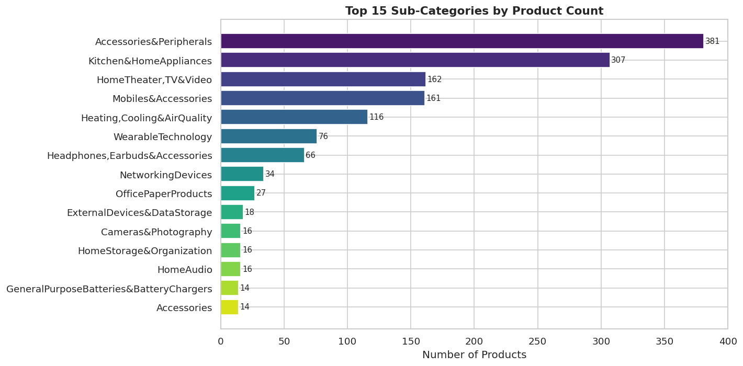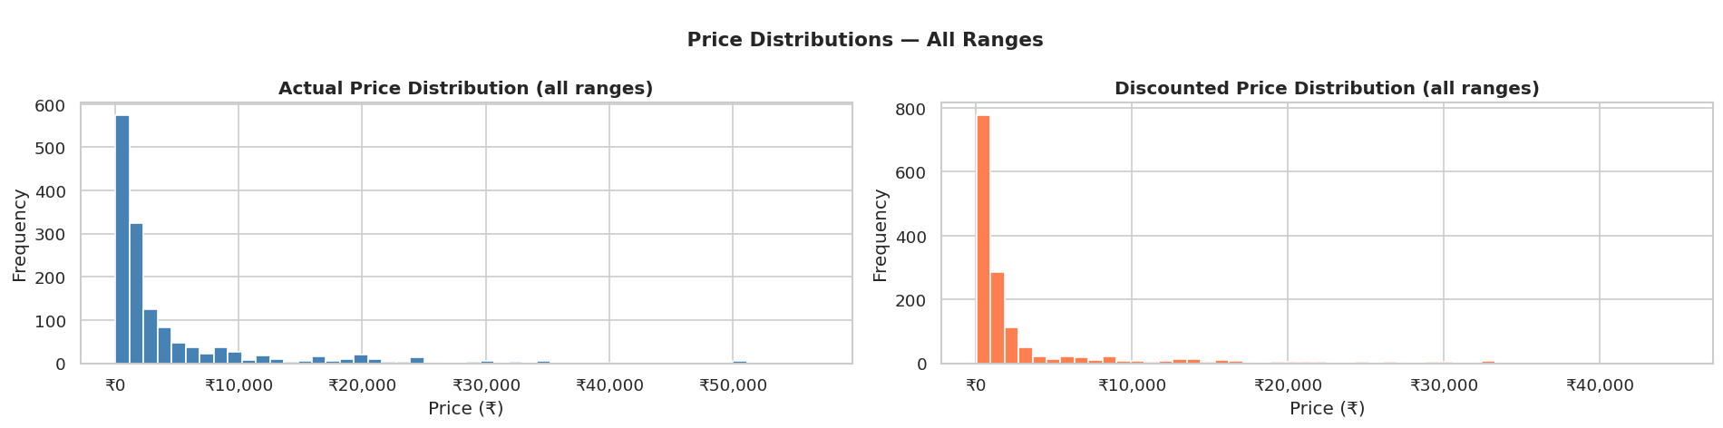
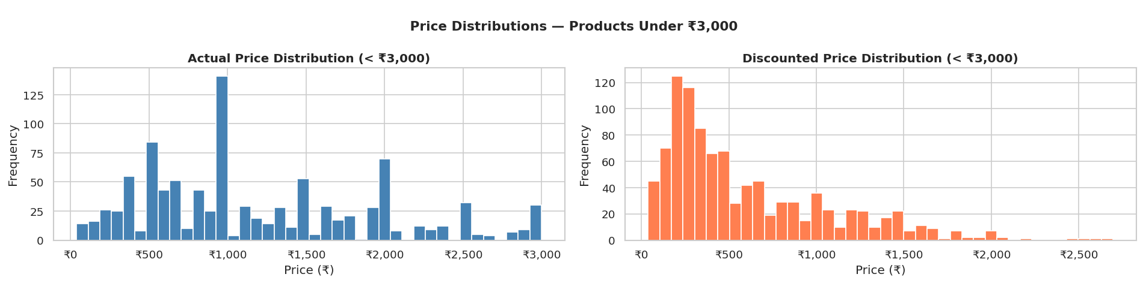

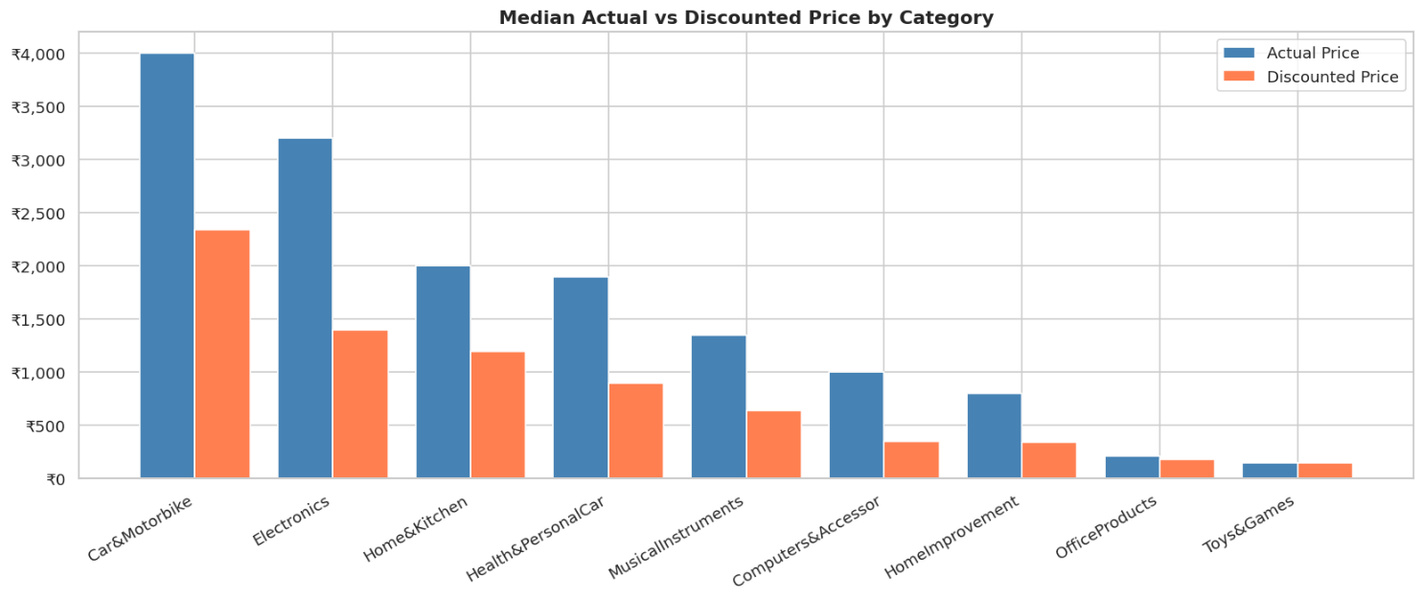

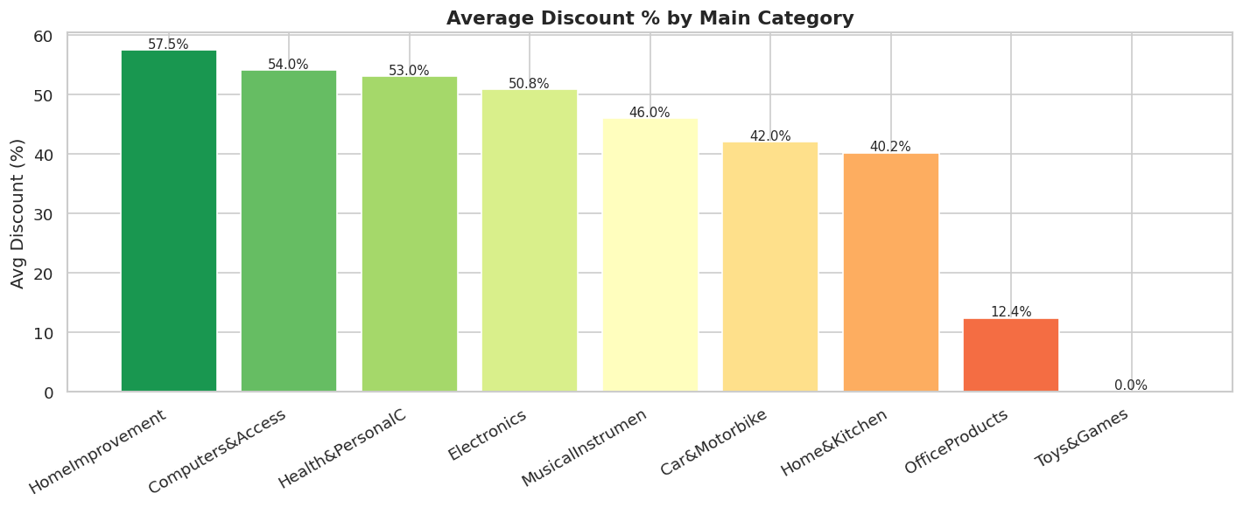
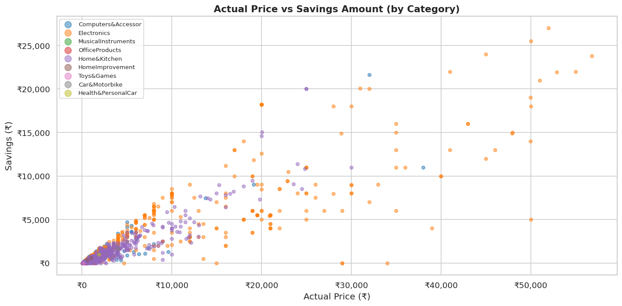
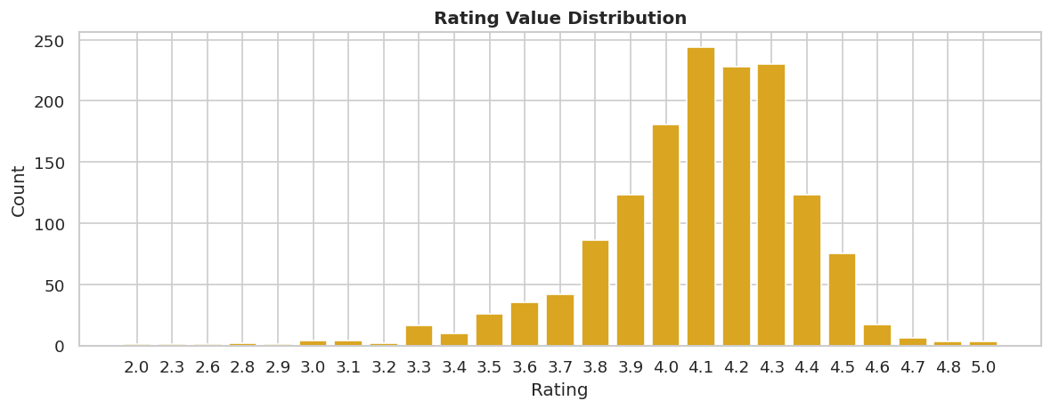
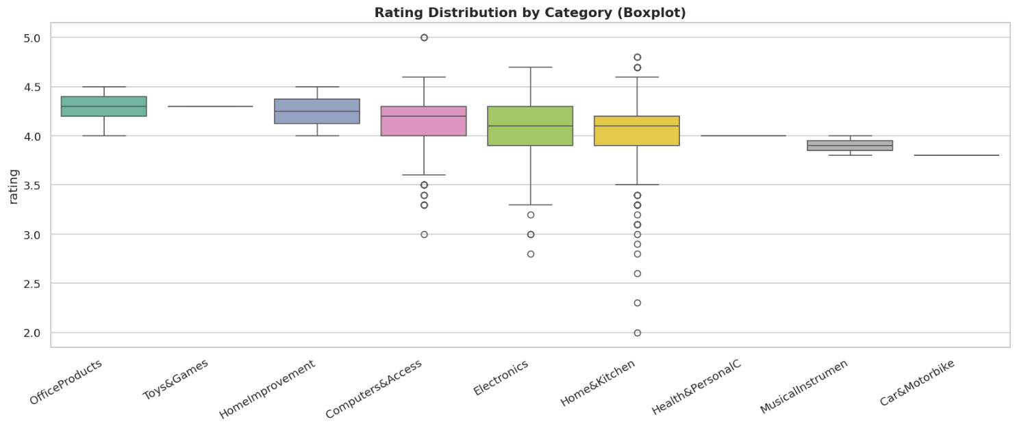
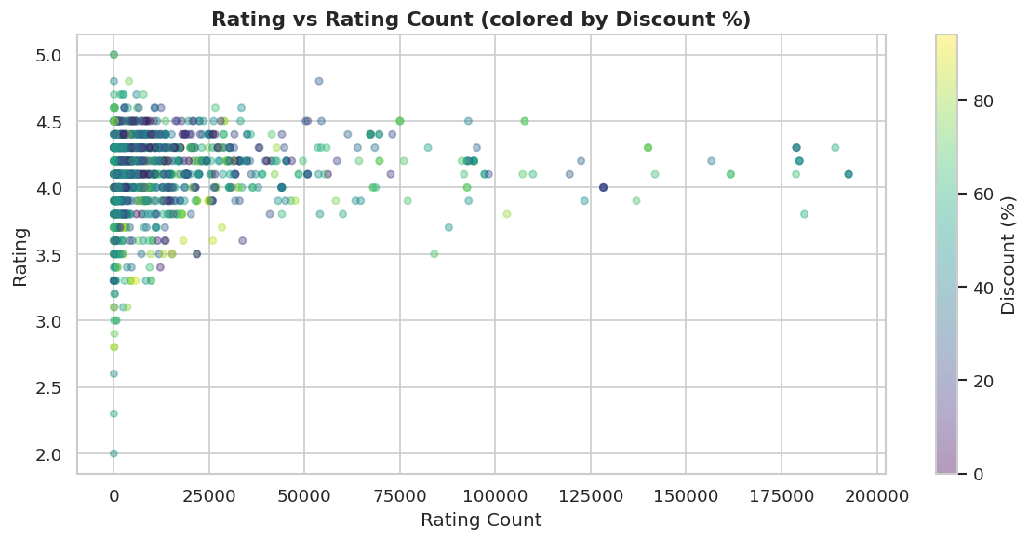
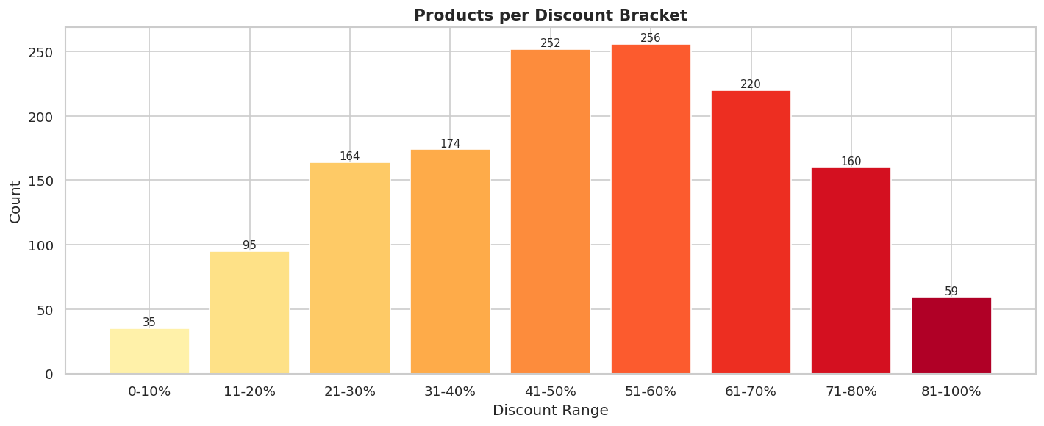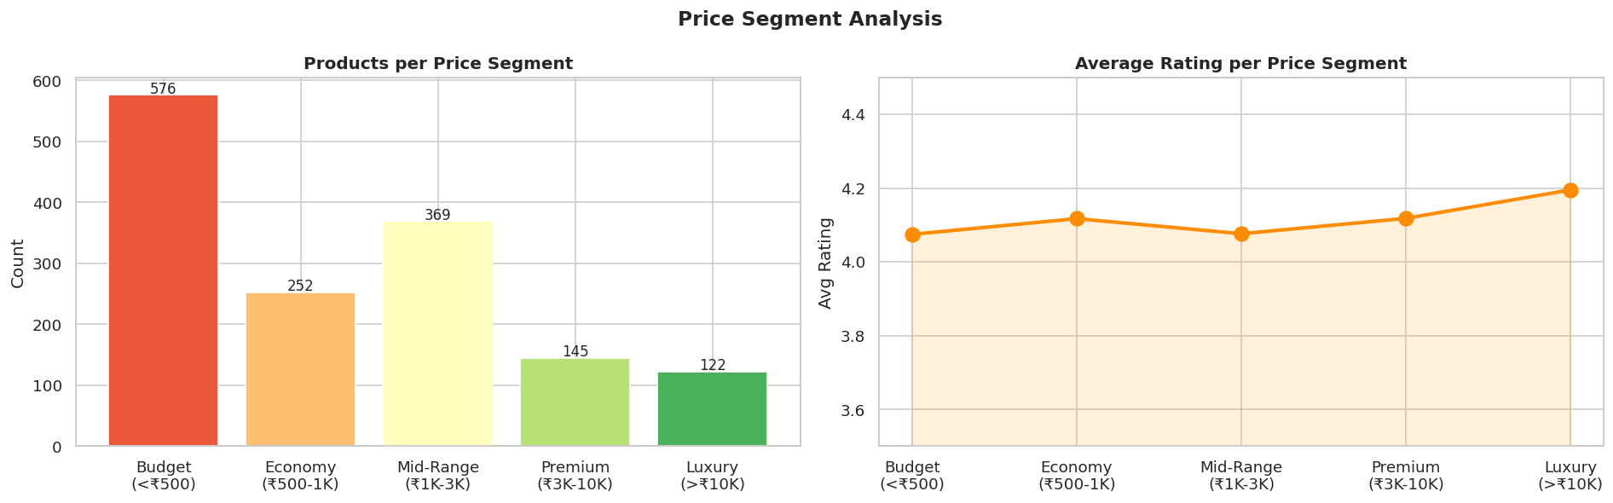
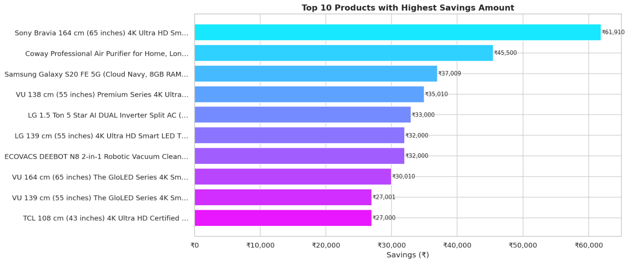

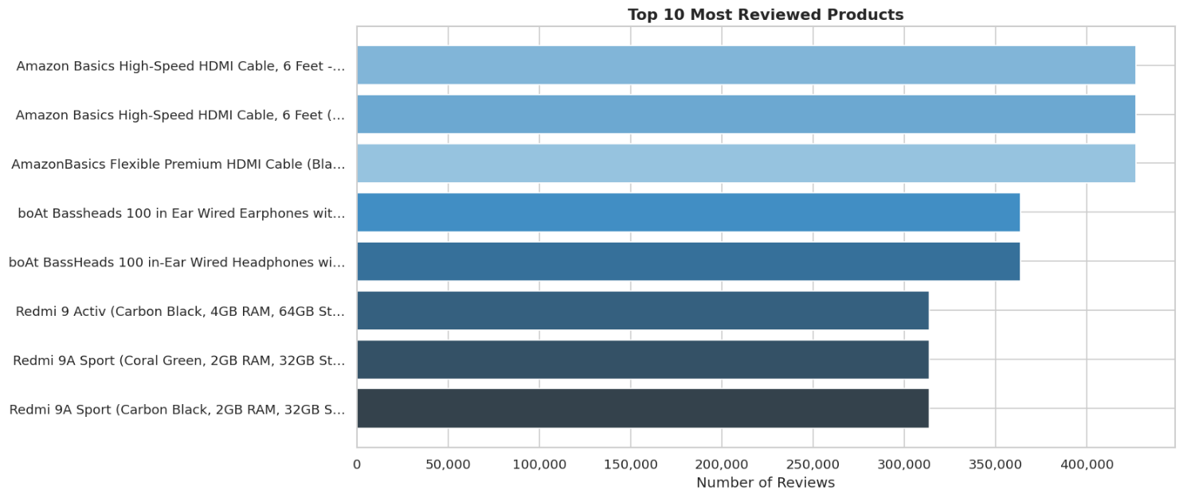
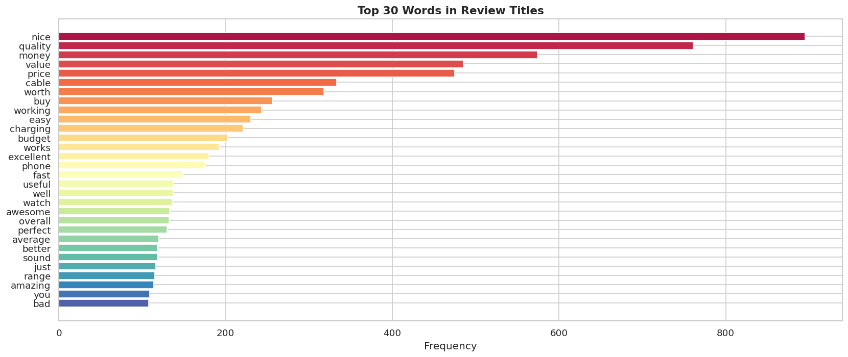

3.1 EDA Summary

=====================================================================
Total products analyzed | 1,464
Unique categories | 9
Average actual price | ₹5,447
Average discounted price | ₹3,126
Average discount | 47.7%
Average savings | ₹2,321
Average rating | 4.10 / 5
-------------------------------------------------------------------------------------------------------------------------
Category Highlights
-------------------------------------------------------------------------------------------------------------------------
Most common category | Electronics
Most discounted category | Home Improvement
Highest rated category | Office Products
=====================================================================

3.3 Recommendation System Output
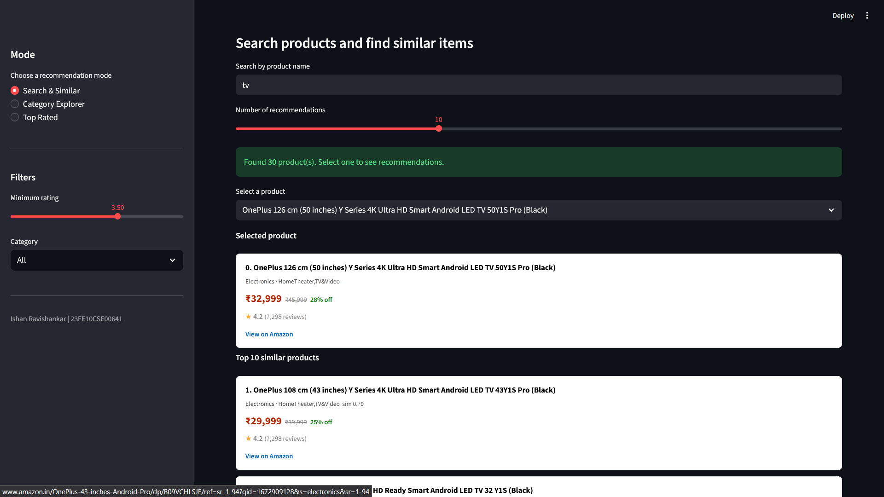

4. Conclusion
This project successfully demonstrates the complete lifecycle of a data analytics solution from raw, inconsistently formatted CSV data to a deployed interactive application. The EDA revealed that the majority of Amazon products in this dataset offer discounts above 40%, that Computers & Accessories dominates the catalogue, and that higher-priced products do not consistently receive better ratings. The TF-IDF recommendation engine produces semantically coherent product suggestions based on textual similarity. The Streamlit application packages these capabilities into three intuitive recommendation modes accessible to non-technical users, making it a practical consumer decision-support tool.

5. Future Scope
- Collaborative filtering – Use user reviews and purchase history to add “customers who bought this also bought” style recommendations.
- Expanded dataset – Include more categories and product types, plus integrate a live Amazon API feed to keep prices and ratings current.
- Sentiment analysis – Analyze review text to enrich ratings with qualitative customer feedback.
- Personalization – Tailor recommendations based on user browsing or purchase patterns.
- Visualization enhancements – Add dashboards or interactive charts so users can explore pricing, discounts, and ratings more intuitively.

